Image Editing

In this section, we'll take a look at some of the ways you can edit and manipulate images with C# and Visual Basic .NET. You'll learn about image rotation, flipping, inverting, filtering, and how to access the individual pixels in an image. You'll also learn how to save the changes to your images.

Start a new project. Add a PictureBox control to your form. In the properties area on the right, locate the Image property. Click the button to the right of the Image property and load an image into your PictureBox control.

Image Rotation

Image rotation is quite easy, as there is a method called RotateFlip.

Add a button to your form. Set the Text property of the button to Rotate. Double click your new button to open the code stub for it. Now add the following line in C#:

Bitmap bmp = new Bitmap(pictureBox1.Image);

Or this in Visual Basic:

Dim bmp As Bitmap = New Bitmap(PictureBox1.Image)

This line creates a new Bitmap object called bmp. There are quite a lot of overloads that the Bitmap constructor can take. One of these overloads just accepts an image object between the round brackets. We're using an existing image between the round brackets of our Bitmap constructor. The image is the one from the PictureBox called pictureBox1.

Once we have a Bitmap object to work with, we can use the RotateFlip method. Add this line to your code: (In VB, just delete the semicolon at the end.)

bmp.RotateFlip( RotateFlipType.Rotate90FlipNone);

In between the round brackets of RotateFlip you start with a RotateFlipType. As soon as you type a dot after RotateFlipType you'll see a list of options. These ones:

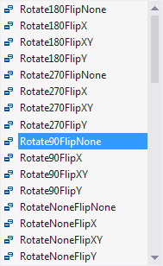

We've gone for the one that rotates the image 90 degrees but doesn't flip it (you'll see what Flip does soon).

The only other line of code you need here is to assign your new bitmap image to the PictureBox Image property:

C#
pictureBox1.Image = bmp;

VB
PictureBox1.Image = bmp

When this line executes, your new Bitmap image will replace the image that was in the PictureBox previously.

Before trying it out, you can wrap all three lines of code in an if statement, just in case the picture box is empty:

C#:

if (pictureBox1.Image != null) {

}
else {
MessageBox.Show("No Image");
}

VB
If PictureBox1.Image IsNot Nothing Then

Else
MessageBox.Show("No Image")
End If

Your code should look like this in C#:

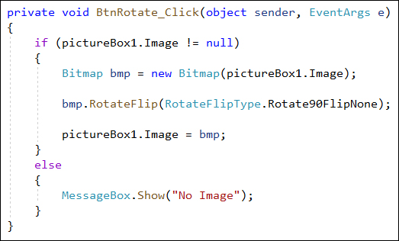

And this in VB Net:

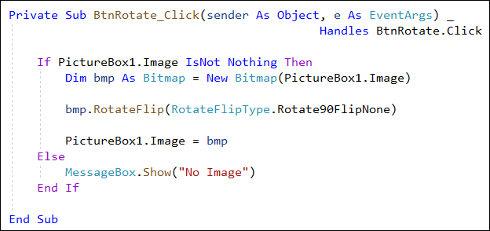

What the if statement does is to check if an image has been loaded into the PictureBox. This is done by testing for "Is Not Null" in C# and IsNot Nothing in VB Net.

Try it out. Run your program and load an image into the PictureBox, if you haven't already. Now click your button. Before rotating, our image looked like this:
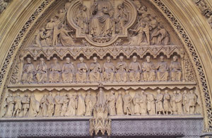

After rotating 90 degrees, the image looks like this:

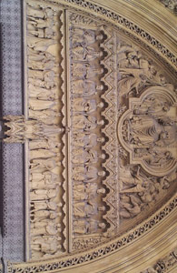

If you keep clicking your button, the image will rotate 90 degrees for each click, until it ends up in the same rotation.

Exercise
Try out some of the other RotateFlipType options and see what they do.

Image Flipping

Image flipping is pretty much the same code we had for rotating. The only difference is in selecting one of the other RotateFlipType options.

Add a new button to your form. Now add the following code in C#:

Bitmap bmp = new Bitmap(pictureBox1.Image);

bmp.RotateFlip(RotateFlipType.RotateNoneFlipX);

pictureBox1.Image = bmp;

And this in Visual Basic:

Dim bmp As Bitmap = New Bitmap(PictureBox1.Image)

bmp.RotateFlip(RotateFlipType.RotateNoneFlipX)

PictureBox1.Image = bmp

You can wrap your code in the same IF Statement as before, if you want.

The new RotateFlipType option is highlighted above. It's RotateNoneFlipX. This option applies no rotation but does apply a Flip on the X axis (the one running left to right.

Try it out. Load an image into your picture box and click you Flip button. You'll see something like this before the button is clicked:

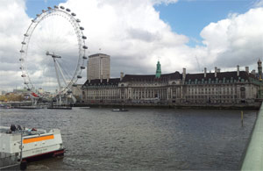

And this after you click your button:

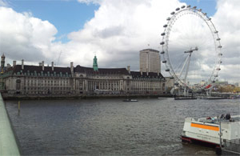

Clone an image

Cloning an image is making a copy of the whole image, or just a part of it. Add a new button to your form and we'll try it out.

The first thing to do is to create a Bitmap of our image from the PictureBox, as before:

C#
Bitmap bmp = new Bitmap(pictureBox1.Image);

VB
Dim bmp As Bitmap = New Bitmap(PictureBox1.Image)

The next thing you need to do is set up a rectangle object. This is used to specify the size of the cloned area. Add the following to you code in C#:

Rectangle rect = new Rectangle(0, 0, 100, 100);

And this in VB Net:

Dim rect = New Rectangle(0, 0, 100, 100)

The line above sets up a new Rectangle object called rect. The first two numbers are the starting point for the rectangle. We're specifying X and Y starting positions of 0, 0. This will get us the top left of our image. The next two numbers, (100, 100) are the width and height of the rectangle.

Now that we have a rectangle set up, we can use the Clone method of Bitmap objects. Add this rather long line to your code:

C#

Bitmap cloneImage = bmp.Clone(rect, System.Drawing.Imaging.PixelFormat.DontCare);

VB Net
Dim cloneImage As Bitmap = bmp.Clone(rect, Imaging.PixelFormat.DontCare)

The first thing we do is to set up a new Bitmap image called cloneImage. After an equal sign we have our previous Bitmap object (bmp). This, remember, holds the image from the PictureBox. After typing a dot, add the Clone method. The Clone method takes two arguments between its round brackets. The first is a rectangle object. This is needed in order to tell Visual Studio which area of the image you want to clone. For us, this was an area 100 by 100, starting at position 0, 0.

The second argument is rather curious. It's this:

System.Drawing.Imaging.PixelFormat.DontCare

Incidentally, in C#, you can add a using statement at the top of your code.This:

using System.Drawing.Imaging;

Then that long line can be shortened to just this:

PixelFormat.DontCare

Visual Studio needs to know the pixel format for the image. This refers to the quality of each pixel in the image you want cloned.PixelFormat is part of the System.Drawing.Imaging namespace. Type a dot after PixelFormat and you'll see the following list of options:

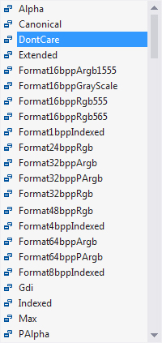

We're not too fussy about the image quality so we've gone for the splendidly-named DontCare option.

The only other thing to do is to transfer the cloned image to the PictureBox:

pictureBox1.Image = cloneImage;

The whole of your code should now look like this in C#:

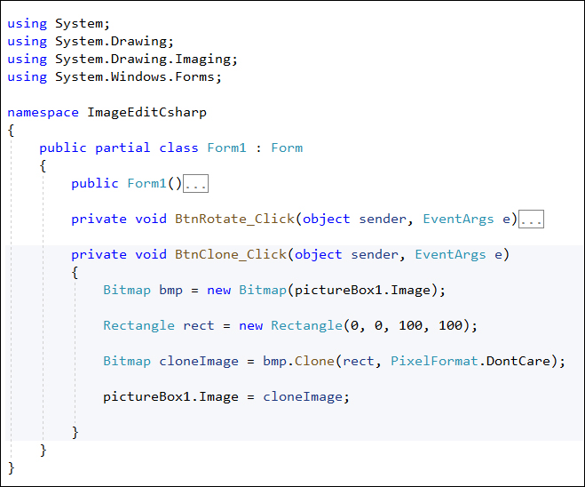

And this in VB Net:

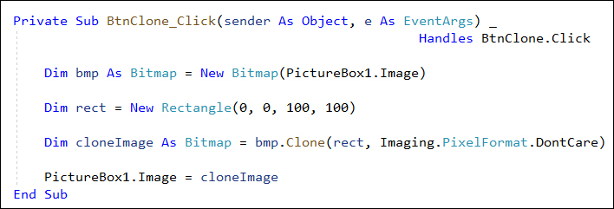

Try it out. Make sure there is an image loaded into your PictureBox (you can add the if statement that checks for this, if you like). Click your Clone button. Before the image is cloned ours looked like this:

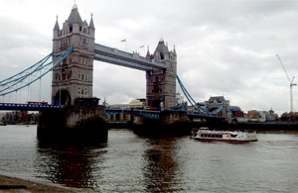

After the clone, we're left with this:



Manipulating Image Pixels

You can manipulate each pixel of your image to get some really nice effects. We're going to add a colour filter to an image. A red filter added to the London Bridge image above, for example, would look like this:

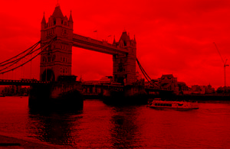

The code for manipulating pixels, is however, slightly more difficult than for rotating, flipping and cloning. We'll need to get a pixel's colour, create a new colour based on that pixel's colour, then set a new pixel colour.

Add a new button to your form. Double click the button to open up its code stub. Create a Bitmap from your PictureBox as before:

C#

Bitmap bmp = new Bitmap(pictureBox1.Image);

VB

Dim bmp As Bitmap = New Bitmap(PictureBox1.Image)

Now add these two variables to your code:

C#

int x, y;

VB
Dim x As Integer
Dim y As Integer

We need these because we're going to be using a double for loop, one inside the other. Add this double for loop to your code in C#:

for (x = 0; x < bmp.Width; x++)
{
for (y = 0; y < bmp.Height; y++)
{

}
}

And this one in VB:

For x = 0 To bmp.Width - 1

For y = 0 To bmp.Height - 1

Next

Next

The outer loop goes from 0 to the width of the Bitmap object called bmp. The inner loop goes from 0 to the height of the bmp object. Inside the inner loop, we'll get the x an y values. The first time round the outer loop the x variable will be 0. The inner loop is then executed in full, with the y variable being used. So you'd get these values the first time round:

x=0; y=1
x=0; y=2
x=0; y=3
x=0; y=4
x=0; y=5
x=0; y=6
etc,

If that's not too clear, take a look at this checker-board pattern:

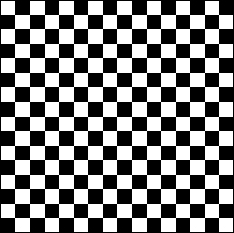

This pattern is a square 16 pixels by 16. What our two loops do is to go from left to right, first of all. At the end of the line, we then drop down and go through the second row. All rows are then accessed from top to bottom.

Add this line to your inner for loop:

C#

Color oldPixelColor = bmp.GetPixel(x, y);

VB
Dim oldPixelColor As Color = bmp.GetPixel(x, y)

We're setting up a Color object here and calling it old_pixel_colour. After the equal sign we have this:

bmp.GetPixel(x, y);

We're accessing the Bitmap object called bmp, which holds the image from the PictureBox. After a dot we have an inbuilt method called GetPixel. This gets the colour of a pixel. In between round brackets you type the coordinates of the pixel whose colour you want to grab. We have x, y inside the round brackets. The first time round our outer loop x will have a value of 0. The first time round our inner loop, y will also have a value of 0. So the first pixel we grab is at 0, 0 from our image, which would be the first white square top, left of our checkerboard image. The second time round the inner loop the x and y values will be 0 and 1, which would get us the first black square from the left on the top row of the checkerboard image.

The next line to add to your inner loop is this:

C#
Color newPixelColor = Color.FromArgb(oldPixelColor.R, 0, 0);

VB
Dim newPixelColor As Color = Color.FromArgb(oldPixelColor.R, 0, 0)

We're new setting up a new Color object and calling it new_pixel_colour. After an equal sign, we have this:

Color.FromArgb(oldPixelColor.R, 0, 0);

What we're doing here is creating a new colour based on the old one. To do that, we're using a method of the Color object called FromArgb. Ignore the A part for now (it stands for Alpha, and we'll get to it soon). The rgb part stands for Red, Green, Blue. This means the Red, Green, and Blue parts of a pixel. Our old pixel colour was white. This has a RGB of 255, 255, 255. A value of 255 means turn the colour full on. So the red part is turned full on, the green part is turned full on and the blue part is turned full on. This gives you a colour of white.

To turn the old white colour into red, we need to switch the red full on and the green and blue parts full off. This is done between the round brackets of FromArgb:

oldPixelColor.R, 0, 0

When you type a dot after the variable oldPixelColor you'll see the following list:

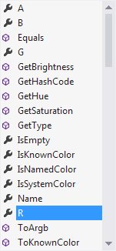

The B, G and R items allow you to get the Red, Blue and Green colour parts of a pixel. We're just getting the Red part. We're setting the Green and Blue parts to 0, meaning don't get these colours at all.

Remember, though, it's the just the Red part of the old colour. The old colour was white, which is RGB 255, 255, 255. We just want the first 255, the red part. We're setting the other 255's to 0.

Now that we have a new colour from the old one, we can set a pixel. Add this line to your inner loop (without the semicolon on the end for VB):

bmp.SetPixel(x, y, newPixelColor);

The SetPixel method sets a colour for a pixel. In between round brackets you first specify the location for your new pixel. Our location is held in the x and y variables, which will be 0, 0 the first time round both loops. After a comma, we type the new colour we want for the pixel in this position. So we've changed the pixel from white to red.

The second time round our inner for loop we get a black square. The colour black has a RGB value of 0, 0, 0. When we use FromArgb again we still get just the red part of those three numbers. The red part is 0. The new colour will, therefore, still be black.

When the loop is finished, the code above would turn a black and white checker-board pattern to this:

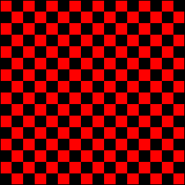

If we wanted the checkerboard to go from white and black to yellow and black the FromArgb line would be this (again without the semicolon on the end for VB):

Color.FromArgb(oldPixelColor.R, oldPixelColor.G, 0);

This time, we're grabbing the Red and Green parts of the old colour. If the old colour is white (255, 255, 255) then the new RGB is 255, 255, 0. Turning red full on, green full on and blue off gives you yellow.

The final line to add is outside of the two loops:

C#

pictureBox1.Image = bmp;

VB
PictureBox1.Image = bmp

This sets the PictureBox image to the new version of the bmp image.

Here's what your code should look like in C#:

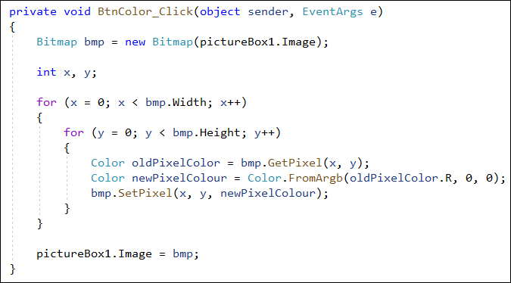

And here it is in Visual Basic:

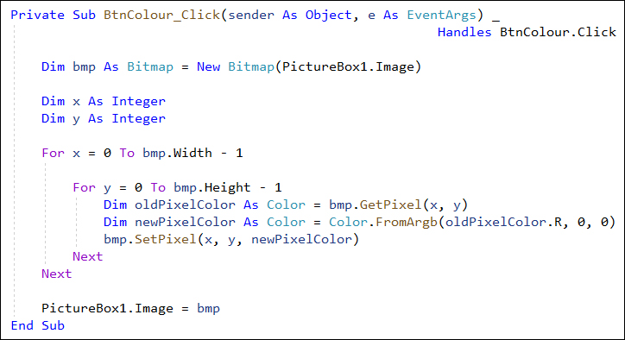

Run your program and load an image into your PictureBox. Click your Filter button and it should turn red. As an exercise, amend your code so that the filter is blue instead of red.

Finally, a word about the A part of the FromArgb method.

The A stands for Alpha. An Alpha value is a measure of how transparent you want the colour of your pixels. A value of 0 means fully transparent, while of value of 255 means fully opaque. The default is 255. If you wanted to turn the opacity down a bit, you'd do it like this:

C#
Color newPixelColor = Color.FromArgb(100, oldPixelColor.R, 0, 0);

VB

Dim newPixelColor As Color = Color.FromArgb(100, oldPixelColor.R, 0, 0)

The Alpha value goes as the first argument to FromArgb. Here's our London Bridge image again. The one on the left has an Alpha value of 255. The image on the right has an Alpha value of 100 set for it:



Invert Pixel Colours

Colour inversion is the colour left over when you deduct one RGB value from 255, which is the highest RGB value you can have. For example, take white. It has an RGB of 255, 255, 255. The invert is 0, 0, 0. This is because we first take 255 and deduct the Red part, which also 255. 255 minus 255 is obviously 0. Do the same for the Green and Blue values and you end up with black. Another example is this colour: RGB(255, 182, 193). This is a light pink. To get the inverted colour we first deduct the red part from 255, which leaves 0. To get the green part we deduct 182 from 255 which is 73. To get the blue part we deduct 193 from 255, which is 62. So the new inverted colour is RGB(0, 73, 62), which is a sort of green/blue colour.

The code to do an inversion on a whole image is just about the same as for changing the pixel colours above. The only difference is the FromArgb line:

Color newPixelColor = Color.FromArgb( oldPixelColor.R, 0, 0);

We need to deduct the old pixels value from 255. The new line, then is this:

Color newPixelColor = Color.FromArgb(255 - oldPixelColor.R, 255 - oldPixelColor.G, 255 - oldPixelColor.B);

The whole of the code to invert a colour is as follows:

C#

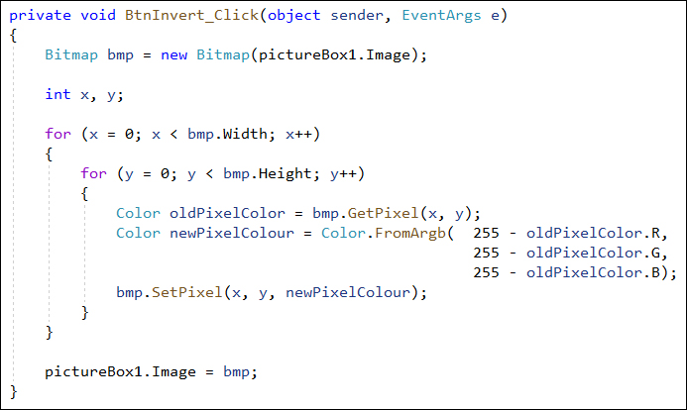

VB

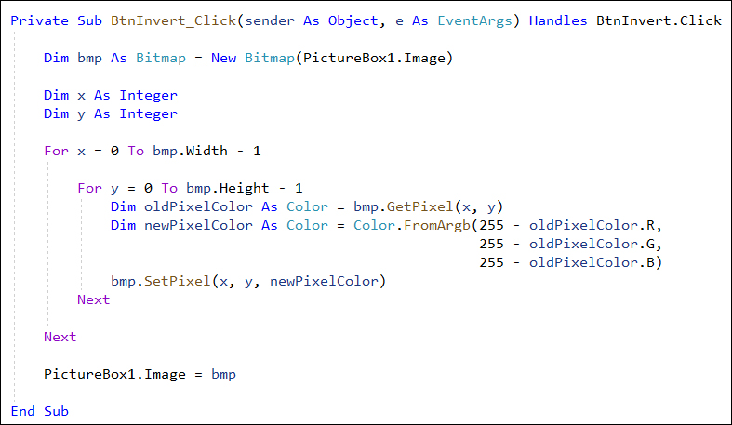

As you can see, it's the same as before except for that one newPixelColor variable line.

Add a button to your form. Change the text property to Invert. Add the code above. When you run your form, here's what an image would look like before the button is clicked:

And here's what it looks like after it has been inverted:

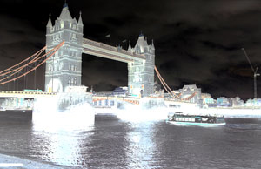

Saving an Image

You'll be glad to know that saving an image is quite easy!

Add a SaveFileDialog control to your form from the C# toolbox. Change the Name property to saveFD. Add a new button to your form and change the Text property to Save. Double click your button to get at the code stub. Now add the following:

C#
saveFD.InitialDirectory = Environment.GetFolderPath(Environment.SpecialFolder.MyDocuments);

saveFD.FileName = "Save Image";
saveFD.Filter = "JPEG|*.jpeg";

VB
saveFD.InitialDirectory = Environment.GetFolderPath(Environment.SpecialFolder.MyPictures)

saveFD.FileName = "Save Image"
saveFD.Filter = "JPEG|*.jpeg"

We've already covered Save dialogue boxes in a previous section, so we won’t explain what it all means here. But we're just setting the save directory to default to the My Documents folder in Windows (or the MyPictures folder, whichever you prefer). The filter has been set to JPEG images. You'll see why in a moment.

Now add the following if statement in C#:

if (saveFD.ShowDialog() != DialogResult.Cancel)
{

}

And this one in VB Net:

If saveFD.ShowDialog() <> DialogResult.Cancel Then

End If

As the first line of your if statement add these two lines:

C#

savePath = saveFD.FileName;

Bitmap bmp = new Bitmap(pictureBox1.Image);

VB

Dim savePath As String = saveFD.FileName

Dim bmp As Bitmap = New Bitmap(PictureBox1.Image)

The dialogue boxes, remember, just return a file path – they don't actually save anything. We're putting the FileName into the string variable we've called savePath. The next line just gets the picture from the PictureBox, as before.

To do the actual saving, you can use the Save method of Bitmap objects.

The Save method has many alternatives. But one of them uses two arguments: a file path and an image format. Add this line to your if statement in C#:

bmp.Save(savePath, ImageFormat.Jpeg);

And this one in VB Net:

bmp.Save(savePath, Imaging.ImageFormat.Jpeg)

(If you didn’t add using System.Drawing.Imaging statement at the top in C# then add System.Drawing.Imaging.ImageFormat.Jpeg between the round brackets of Save.)

In between the round brackets we first have our file path. After a comma, we have this:

ImageFormat.Jpeg

ImageFormat is a class in the System.Drawing.Imaging namespace. When you type the dot after ImageFormat you'll see a list appear. This one:

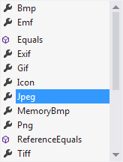

This is a list of image formats that the Bitmap can save to. We've gone for the JPEG image format.

As the final line of the Save code you can add a message box, if you like. The whole of the code would then look like this in C#:

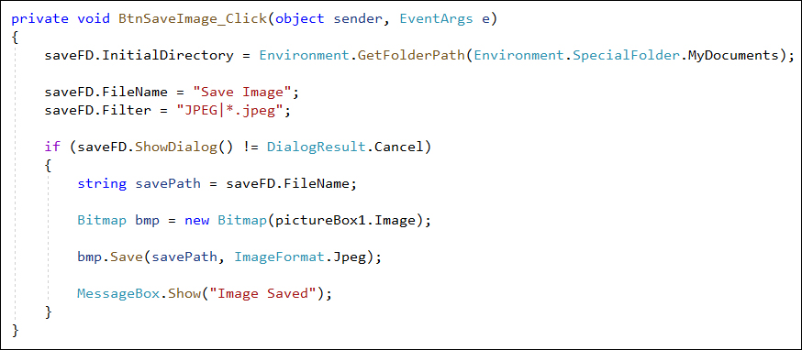

And this in VB Net:

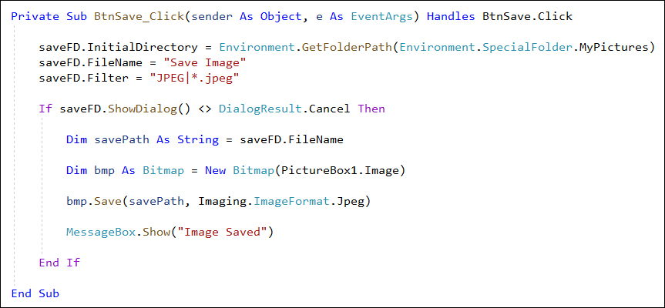

Run your program and test it out. Load an image into your PictureBox. Click one of your buttons, such as Filter or Invert. Then click your Save button. You should find that you'll have a new image in your My Documents or My Pictures folder.

And that's it for image manipulation. We hope it has whetted your appetite to explore more! In the next section, you’ll see how to send and receive emails with C#. We’ll create a project with Tabs for this.

